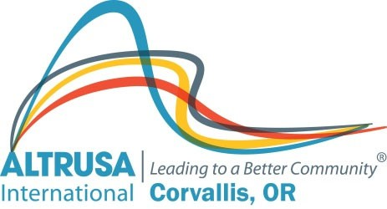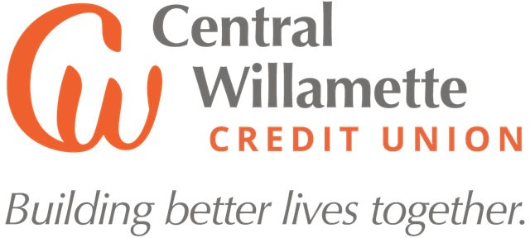

ALTRUSA & CENTRAL WILLAMETTE CREDIT UNION CONTINUING EDUCATION SCHOLARSHIP
The Altrusa Club of Corvallis & Central Willamette Credit Union Continuing Education Scholarship is a nonrenewable $2,000 award.

QUALIFICATIONS: To be eligible to receive this scholarship, you must:
- Be an older than average student living in Benton County
- Be returning to education after a break
- Submit an unofficial transcript
- Provide one letter of reference (not from a member of Altrusa or the Credit Union)
  - Name of person submitting reference
  - Phone number
  - Email address
- Email (1st choice) or mail the application, unofficial transcript, and one letter of reference by April 1, 2024 to Tammy Skubinna, 1868 NW Lance Way, Corvallis OR 97330; 541- 760-4221; Skuby1@comcast.net.

The Continuing Education Scholarship funds will be distributed when the student enrolls in the fall 2024 term.
APPLICATION FORM: Answer the following questions. You may add extra pages if you need them. Please type this form for easy reading & send by email if possible.

Name Phone

Address City Zip

Email

- Where do you intend to go for your continuing education/training?

- Have you applied? Yes No

- Have you been accepted? Yes Not yet

- Tell us your story. What skills have you developed from your past paid or volunteer experience? What has led you to want to continue your education?

- What are your plans or goals for your future? How would this scholarship help you to attain those goals?

- What funds do you have available to help you pay for your further education?

- Are you able to apply for financial aid? Yes No

- If you are eligible for financial aid, have you filled out the FAFSA form?
Yes No

- Where did you hear about this scholarship (college, newspaper, web site, Facebook, etc.)?

MAIL YOUR APPLICATION MATERIALS BY APRIL 1, 2024. You will be notified by email when your complete application is received.

