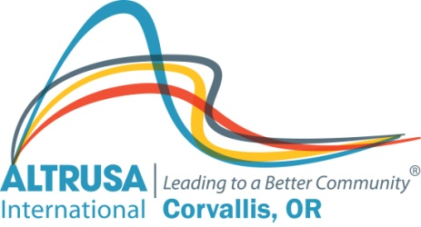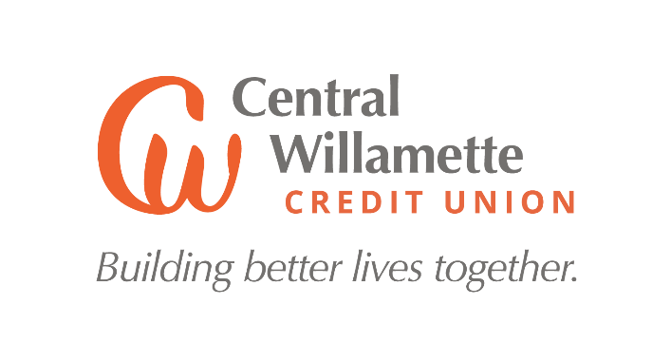
The Altrusa Club of Corvallis & Central Willamette Credit Union Latinx Scholarship is a nonrenewable (one time) $2,000.00 award.
QUALIFICATIONS: To be eligible to receive this scholarship, you must:
- Be a graduating Benton County High School Latinx Student
- Answer the questions on this application form
- Submit an unofficial transcript
- Provide one letter of reference (not from a member of Altrusa)
  - Name of person submitting reference _______________________
  - Phone number __________________________________
  - Email address________________________________________
  - Email (1st choice) or email the application, unofficial transcript, and one letter of reference by April 3, 2023 to Tammy Skubinna, 1868 NW Lance Way, Corvallis, OR 97330; 541-760-4221; Skuby1@comcast.net.

The Latinx Scholarship funds will be distributed when the student enrolls in the fall 2023 term.
APPLICATION FORM: You may add extra pages if you need them. Please type this form for easy reading & send by email if possible.

Name _____________________________________Phone __________________

Address _____________________________ City _____________Zip ________

Email _________________________________________________

- Where do you intend to go to college/vocational training? _________________________

- Have you applied? ____ Yes ____ No

- Are you accepted? ____ Yes ____ No

- List the clubs, teams and other organizations (include volunteer work) you have been involved with while you have attended high school.

- List any paid work you have done and the skills you have gained from work experience.

- Tell us your story. What are your plans for your future and how would this scholarship help you?

- What funds do you have available to help you pay for college/vocational training? How much is your family able to pay?

- Are you able to apply for financial aid? ____ Yes ____ No

- If you are eligible for financial aid, have you filled out the FAFSA form?
____ Yes ____ No

- Where did you hear about this scholarship (school, newspaper, web site, Facebook, etc.)?

MAIL YOUR APPLICATION MATERIALS BY APRIL 3, 2023. You will be notified by email when your complete application is received.

